**UXG Content Development Process**

July 6, 2020

# UX Guide (UXG) Website Teams and Roles

The following teams were established to support the UXG website development process. Each team has lead entity and person, and possibly a secondary lead.

| **UX Guide (UXG) Teams/Roles** | **Entity** | **Responsibility/Function** |
| --- | --- | --- |
| Product Manager (PM) | VHA HFE Ross Speir | Define UXG features and development objectives per release/month. |
| Project Manager (PjM) | BAC  David Clarke | Define timelines, allocate resources, ensure objectives are clear and fulfilled. |
| Discovery Team | HFE  Stephanie Tallett  BAC Teri Brooks, Lead | Identify and engage with targeted users of the website with HF methods to gather data on use scenarios, workflow, and objectives that can be supported by the website. |
| Design Team | BAC  Naomi Daniels, Lead | Design and develop content and user interface |
| Development Team | BAC  Eric Wald, Lead | Implement design and content in WordPress; authority and autonomy to make decisions, execute work, and oversee quality. |
| User Testing Team | BAC Teri Brooks, Lead | Conduct user testing sessions on interfaces and content produced by design team or development team. |
| Content Development Manager | BAC  David Clarke, Interim Lead | * Oversee content development (prioritization -> evaluation); improves the process. * Oversee expectations for content quality and consistency. * Coordinate with SMEs / Institutions on content development. * Manage UX Education and Training strategy. |
| Content Development Team (CDT) | HFE Blake Hesselroth, Lead  Current members: Tim Arnold; Kas Adams, Stephanie Tallett | Author content, review content, provide SME input, end user identification and contacts. |
| Editorial Team | BAC  Dan Gajewski, Lead  ~~Tom Cona~~  Michael Gowan  Nina  Steve  Prithima  Abbie  Mak | * Review and editorialize all content to accomplish a unified and consistent voice, tone, and terminology (this does not include review of ‘technical’ content). * Author content (referencing specified sources). |
| Project Management Team | BAC  David Clarke, Lead  Tom Cona, Support  HFE  Ross Speir, Lead | Define and manage the ‘sources’ for content development so that content is produced according to UXG objectives and timelines. |

# UXG Website Content Types

Currently, the following types of content are the focus of the UXG website. Additional types of content will be considered as they are discovered. Each type of content will have a template that will be used by the Editorial Team and other contributors. These templates are in development and will not be completed until September 2020.

### UX Fundamental Concepts

Human-centered design builds on a set of principles that help you create products that put users and their needs first. These concepts create the foundation for the user experience process and provide the underlying reasons for using specific methods.

“If you’re just getting started with human-centered design and the user-experience process — or you want a refresher — start by exploring these topics.”

### Methods

Descriptions of user experience methods — the skills and activities used in human-centered research and design — and instructions on how to apply them in projects to improve usability and user satisfaction.

### Tutorials

Tutorials developed to help users learn a range of human-centered design skills. Developed by user experience experts, each tutorial comprehensively explains ideas through slides, videos, case studies, and more. Apply these skills to your projects and put best practices at the core of your work — resulting in more usable products and a better experience.

### Playbooks

Guides that show how to implement research and evaluation methods — designed for tasks or clinical scenarios within medical centers in the VHA in which multi-disciplinary teams work together.

### Quick Start Guides

Practical, step-by-step advice on how to make user experience a part of your project by combining HCD principles, methods, tools, design guidance, and/or tools customized for your specific project.

### Videos

Videos created by experts describing how user experience research and human-centered design are applied.

### Personas

Defined personas for VHA users to help better understand their goals, tasks, and environments.

### Tools

Templates, checklists, and other tools to help users be successful in integrating UX best practices in their projects.

### Case Studies

Describe how other groups have used the ideas featured on this site to build better products and solutions.

### Design Examples and Guidelines

Download examples and guidelines that describe how to display and enter information for common software tools at the VHA.

### Newsletters

Publications about user experience and human-centered design to further users’ knowledge.

### Glossary

Definitions of terms that we use on this site and learn more about user experience.

### FAQs

Answers to common questions about how user experience and human-centered design can improve your projects.

# Content Development Process Overview

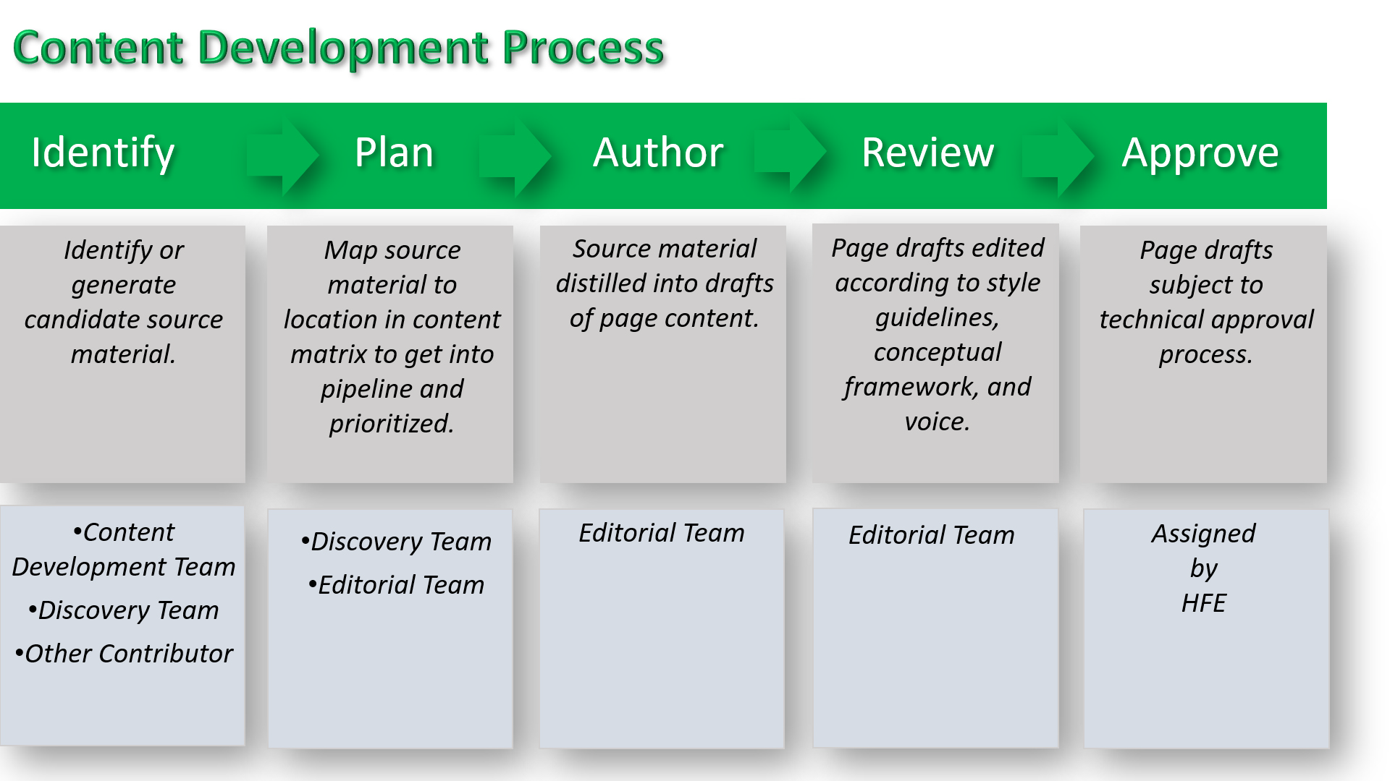

Figure 1. General content development process and teams involved

# Stages of Content Development

## Identify/Discover Content

The UXG PM and Content Development Manager collaborate to define UXG objectives and content needs for each release month based on a defined backlog of content for the UXG MVP.

Airtable will be used to capture the [UXG Objectives](https://airtable.com/tblY8K5grWuSg8G8W/viwpRnNsDlt5q7DcK?blocks=hide) and [Content Needs](https://airtable.com/tbl96Yr5kUamQRJmS/viwooxAFAdwvHRyzf?blocks=hide). Use of different views will display list of objectives (by priority and month) and content needs by priority and source and content type.

Content for the UX Guide can originate from four sources (or paths).

### Content Development Team Source

* CDT provides content recommendations based on their expertise with VAMC, HIT, and as SMEs.
* Content should map to established UXG Business Goals and Objectives

### Discovery Team Source

* While conducting discovery research activities the Discovery Team can capture and report user needs as user stories for the Content Management Manager to review with PM, Editorial Team, and Design Team.
* [User Stories will be captured in Airtable here](https://airtable.com/tblAF0lq8NQ42Uyxb/viwvkbFBGjDth2kez?blocks=hide).

### Editorial Team Source:

* The Editorial team engages with partners such as HFE, IPS, KBS, AMIA 10x10, to collaborate on sharing information, data, and materials related to UXG content topics.
* Editorial team investigates:
  + Who are SMEs to schedule interviews
  + What materials are available for review and analysis
  + Who were the intended users and what were the user needs
  + What were the learning objectives and intended use objectives for each module

### Contributor Source

* Other community partner who is invited to provide content or makes request to have content published to the site.

## Plan

Producing drafts of original written content for standard page types (methods, playbooks, etc.) or linked documents (personas, case studies).

Ross

* + - Identify available content and resources
    - Envision the V1 release
    - Establish UX research competency
    - Prioritize topics for content development (based on highest value to the field)

## Produce/Author

Producing drafts of original written content for standard page types (methods, playbooks, etc.) or linked documents (personas, case studies).

* + - Develop publishable chapters on various UX topics
    - Translate chapters into interactive modules (content decomposed into various UXG components)
    - Publish to the UXG (What do we do with the chapters?)

1. Content Development Team

* CDT authors content that maps to the UXG objectives and content needs.

1. Discovery Team
2. Editorial Team: BAC Primaries: Dan Gajewski, Tom Cona, Michael Gowan

* Contributor: Other community partner who is invited to provide content or makes request to have content published to the site.

## Review

Editing drafts of written content to ensure alignment with site’s conceptual and stylistic frameworks, and to package appropriately for production.

## Approve

Review of content by SME to ensure aligned with disciplinary state-of-the art.

Evaluate or Measure?

* + - Are learning objectives achieved?
    - Are intended use objectives achieved?

# Stages of Design/Evaluate

# Stages of Development (Wordpress)

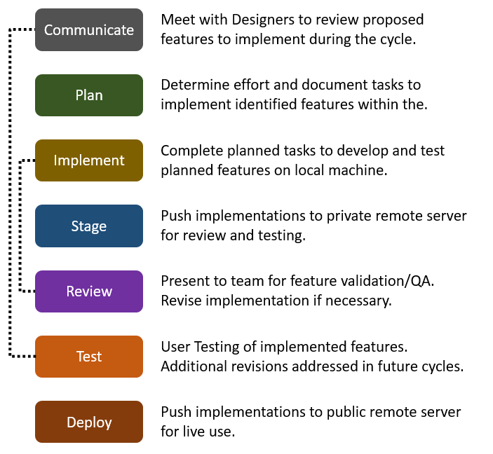

Paths for Content Development

[ ] BAC -> SMEs on the content dev team

* Experience with VA HIS configurations (CPRS)
* Consistency

[ ] UXG content list (ready to share?)

[ ] BAC -> PM support for content development?

* Logistics (below)
* Prep for next week

# Logistics:

* On Tuesday we will focus on UXG content work (minimize distractions from competing projects)
* Tuesday morning call
  + 9CT, 10ET (proposed)
  + Purpose
    - Short term prioritization decisions
    - Content development re: Discovery, writing, feedback reviews
    - Review assessment results from the field
  + Topics NOT to discuss
    - QA discussions
    - UX vs HFE decisions
      * Not a part of the conversation
      * HFE technical methods and UX practice methods
      * Ross feels like they are complementary
      * Likewise, QA

* + Content Dev team, project manager
  + In advance: agenda, project status, required prep for team
  + In the call: note-taker, decisions, action item assignments, next steps, (clarity & accountability - Tana)
  + After the call: send meeting minutes, track action items
* Tuesday afternoon huddle
  + Status update

# Goal of the UX Content Development Team

* Develop content that helps VAMCs improve UX competency
* Leverage VA institutional knowledge of clinical informatics

# Approach

## Establish team roles

* + Lead: Blake Lesselroth
  + UX Research lead: **Stephanie Tallett**
  + Content development team: **Tim Arnold (Clinical Pharmacist), Kas Adams**, MedStar/BAC (with CPRS experience), Jason Sayline (not reached out),
    - Could add Michelle later, from Visionary
  + Content development manager: BAC
    - Manages UX Education and Training strategy
    - Oversees content development (prioritization -> evaluation); improves the process
    - Oversees expectations for content quality and consistency
    - Coordinates with SMEs / Institutions on content development
  + Content Dev team will have the authority and autonomy to make decisions, execute work, and oversee quality
  + Objective:
    - Curriculum topics

## Outline the content development process

### Plan

* + - Identify available content and resources
    - Envision the V1 release
    - Establish UX research competency
    - Prioritize topics for content development (based on highest value to the field)

### Discover

* + - Who are SMEs?
    - What materials are available?
    - What are user needs?
    - What are learning objectives and intended use objectives for each module?

### Produce

* + - Develop publishable chapters on various UX topics
    - Translate chapters into interactive modules (content decomposed into various UXG components)
    - Publish to the UXG (What do we do with the chapters?)

### Evaluate

* + - Are learning objectives achieved?
    - Are intended use objectives achieved?

# **Establish content quality and consistency standards

* + Promote the concept of an interactive UX textbook that unifies
    - contributions of subject-matter experts
    - the evolving UX practice in VA
  + Promote consistent design of information and use of pedagogical components
    - i.e. training modules, methods, terms, key concepts, tools/templates
  + Promote a common ‘UX lexicon’ within the VA informatics community
    - HFE terms for adoption (HF, UX, Informatics…)
  + Attribution for content
  + APA format

# Cadence for developing content

* + Modules will have a Lead Author w/ co-authors
  + Focus on Modules (chapters)
    - Example 1: Mapping workflows
    - Example 2: Measuring value
  + SMEs for various topics are recruited as needed
  + Modules developed a 2-week sprint
    - Preceded by planning and Discovery work
    - Followed by evaluation
  + Typical work during a sprint (notional)
    - Develop content for Module 2
      * Draft the ‘chapter’
      * Build interactive components
      * Publish
    - Get user feedback on and revise Module 1
    - Plan and discovery for Module 3

# Information Sources

* Curriculum from Blake's UX Training workshop
* Materials derived from UX practice at VA
  + Usability Toolkit
  + Field
  + HFE project work
* VA education / training resources
  + AMIA 10x0
  + CDS Eval
  + HFE Newsletters. Brown Bags
* Potential subject matter experts
  + Laura Militello, Brian Moon, Jerry Osheroff
  + Linda Harrington, Jiajie Zhang, Alisa Russ
* Potential Institutions
  + Vandy CRISS Lab (Matt, Shilo)
  + MedStar National Center for Human Factors in Healthcare
  + U Vic School of Health Information Science (A Kushniruk)

# Notes

## **Content suggestions

* Facilitating negotiation of needs from various stakeholder to arrive at a usable solution
* CPRS-specific usability heuristics

## **UX Research suggestion sources

* Request from Primary Care program office for HFE to review recommendations to CHIOS to develop and organize consults
* Identify key projects for a VAMC CHIO team
* Leverage CAC thought leaders – How to institutionalize UX practice at VAMCs
* Capture user needs from the perspective of
  + Roles:
    - CHIO
    - CAC
    - SR coordinator
  + Process
    - LEAF request comes in…
    - CHIO staff revives and responds
    - CHIO prioritizes

## **Principles

* Move at the pace of operations. Focus on content (education, methods, techniques, theory) that is useful in VAMC operations. For example, a Summative Test will never be executed by a site.
* UX practices proven effective for VAMC informaticists (“Informatics UX”) complimented by HFE technical methods